
Good afternoon, all.

Once again can I thank the PTFA and all of their helpers for putting on an amazing summer fair! We really could not complete this without the help and support of our community and I am truly grateful.

We are still counting the profits, but we have estimated that we have made around £1000 profit to go towards the children and their learning. I am over the moon for them all!

Just a reminder, that the year 6 are heading towards the end of their time with us at Milborne Port Primary School and they have parties, assemblies and shows to put on. We are truly proud of how well they have done this year and we know they will go far.

Every child has gone home with a copy of their annual school reports so please look in their book bags and school bags for these. Year 6 will have a copy of their SATs results, Year 1 will have a copy of their phonics screen results and Year 4 will have a copy of their multiplication check results. Please feel free to speak to class teachers if you have any concerns regarding these. I am sure you will be as proud of the children as I am.
Wishing you all a lovely weekend.
Miss Danyali—Headteacher

Friday7th July 2025
Milborne Port Newsletter

STICK it in the DIARY

--14th July: Year 6 show: dress rehearsal to the whole school (no parents)
-15th July: ACE at the Olympics event
-16th July: Year 6 matinee to the parents
-16th July: transition day 2 (whole school)
-17th July: Year 6 evening performance.
-18th July: Beeches final day of term
-18th July: Look and Share (8.35-8.50am)
-18th July: whole school celebration assembly
-17th July, 3.30pm:-PTFA AGM – come & join the team!
-17th July: Year 6 water party
-18th July: whole school celebration assembly
-21st July: Famer Palmer trip for the Beeches
-21st July: Leavers assembly and trophies
- 22nd July: Final day of term for R/ KS1/ KS2
-4th September 2025: Autumn term begins
-3rd October: Harvest festival
-10th December: Christmas Carol Service
-31st March: Easter Church Service





We have some new contact details. Please see below:

Office@milborneport.acexcellence.co.uk

beeches@milborneport.acexcellence.co.uk

SEND@milborne.acexcellence.co.uk



Class attendance winners
This week’s class attendance winners are Crackmore with 98% attendance.



Celebration Assembly



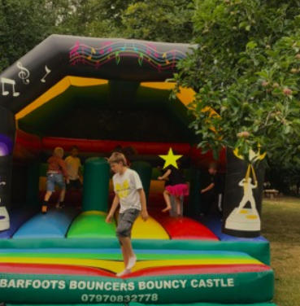
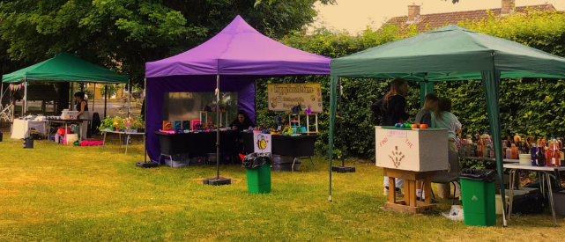
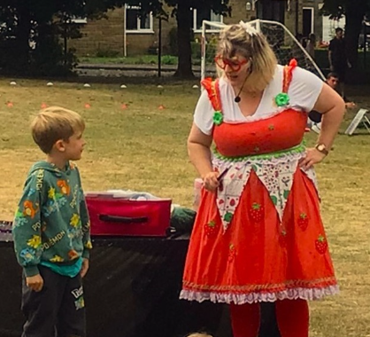




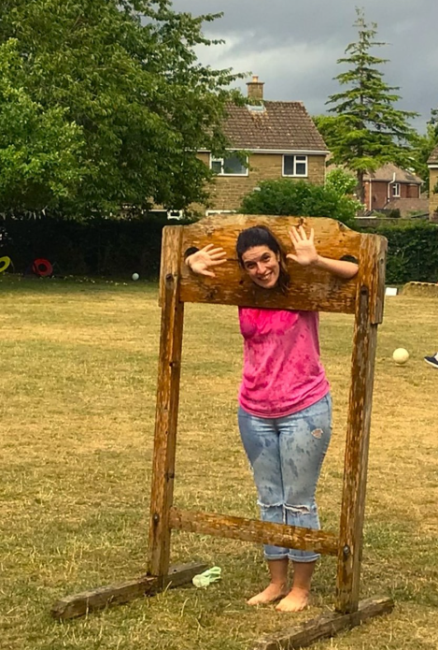



Kingsbury:
Newtown:
Crackmore:



