
Good afternoon, all.
As we reach the end of another busy and fulfilling academic year, we want to take a moment to reflect on everything we’ve accomplished together in 2024–2025. From academic achievements and creative milestones to sporting success and community events, it has been a year to remember.
As we look ahead to the summer break and beyond, we also say a heartfelt goodbye to three much-loved members of our school community: Julie Bartlett, Judy Minney, and Simon Sweatman. Julie, Judy, and Simon have each brought warmth, wisdom, and dedication to their roles over the years. Their commitment to the school, their students, and their colleagues has left a lasting impact, and they will be deeply missed. We extend our sincere thanks to each of them for everything they’ve contributed, and we wish them all the very best in their next chapters.
I would like to say a warm welcome to Mrs Harris, who we have employed as the school deputy head teacher and year 5/6 teacher. More information to come next week regarding this.
Whether you’re heading off on holiday, preparing for new challenges, or just enjoying a well-earned rest, we hope you have a wonderful summer once it arrives next week. Thank you all for being part of this vibrant school community. See you in the new academic year on September 4th!

Miss Danyali—Headteacher

Friday 18th July 2025
Milborne Port Newsletter

STICK it in the DIARY

--14th July: Year 6 show: dress rehearsal to the whole school (no parents)
-15th July: ACE at the Olympics event
-16th July: Year 6 matinee to the parents
-16th July: transition day 2 (whole school)
-17th July: Year 6 evening performance.
-18th July: Beeches final day of term
-18th July: Look and Share (8.35-8.50am)
-18th July: whole school celebration assembly
-17th July, 3.30pm:-PTFA AGM – come & join the team!
-17th July: Year 6 water party
-18th July: whole school celebration assembly
-21st July: Famer Palmer trip for the Beeches
-21st July: Leavers assembly and trophies
- 22nd July: Final day of term for R/ KS1/ KS2
-4th September 2025: Autumn term begins
-3rd October: Harvest festival
-10th December: Christmas Carol Service
-31st March: Easter Church Service





The winners of our sunflower competition are………………………………………………
NEWTOWN CLASS.
Newtown class grow the tallest sunflower and were given a lovely fruity lolly as their prize.
Well done to all the children and teachers that took part.



Class attendance winners
This week’s class attendance winners are Venn class with 95% attendance.

👋 Farewell, Year 6! 🎉
As the school year comes to a close, we say a fond farewell to our wonderful Year 6 pupils. You’ve grown so much—both in your learning and as young people—and we couldn’t be prouder of all you’ve achieved.
From classroom projects to school trips, performances, and sports days, you’ve brought energy, kindness, and enthusiasm to everything you’ve done. Now, as you take the exciting step into secondary school, we know you’ll continue to shine and make us proud.
Thank you for the memories, Year 6. We'll miss you—but we can’t wait to hear about all the amazing things you go on to do!
Congratulations on your fabulous end of year performance in Cinderella and Rockafella.

Wishing you all the best for your next adventure. 🌟

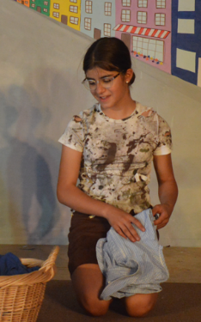
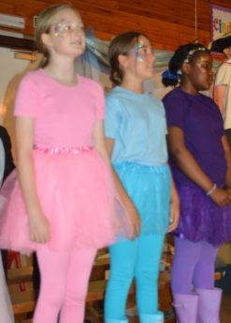
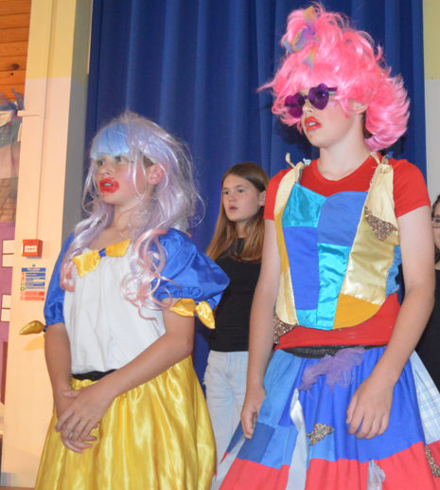
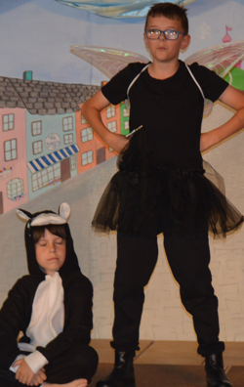
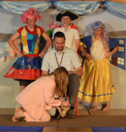
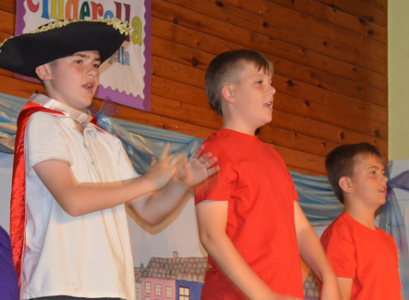



Celebration Assembly

Gainsborough: Emma, Matthew & Bonnie
Medlycott: Nevaeh, Seth M & Esra
Venn: James, Oslo, Arthur & Arlo
Kingsbury: Alaia, Abongwe, Louis & Olivia R
Newtown: Sofia, Faith, Owen & Jack
Crackmore: Rayna, Darlene, Iarina & Rowan

Year 5: King Arthur’s for the day!
Last week, year 5 students visited our local secondary school- King Arthur's. They spent the day completing lots of aspirational activities and worked alongside the amazing secondary school teachers. The pupils were compassionate, driven and responsible members of our school. Well done year 5!

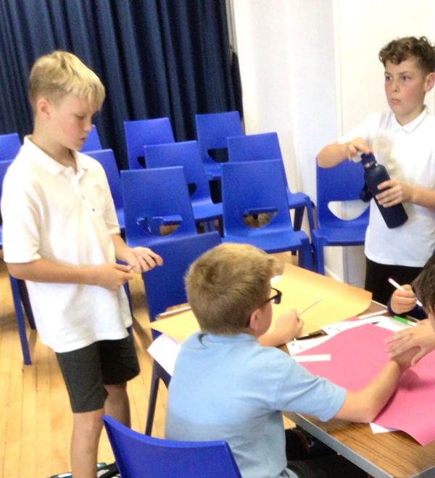
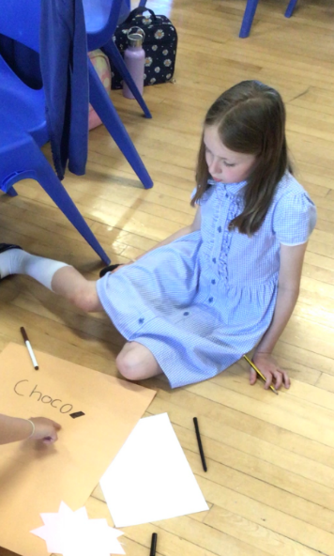


Wow- what an amazing sporting day we had at ACE at the Olympics in Exeter Arena. Milborne Port Primary School made us all proud. What determined, compassionate and sporting children. We are so lucky to have you all at our school! We competed with 20 schools for our trust and won 3 medals overall.
Congratulations to our amazing two winners! Rowan came 2nd in the long jump final as well as 3rd in the 100m final, and Iarina also came 3rd in the 100m final.

