
Good afternoon, all.
What a beautiful, sunny week we have had. Can I please take this opportunity to ask you to send your children in with water bottles, sun hats and with sun cream applied in the morning. We endeavour to keep the children as cool as we can in class and encourage them to take multiple breaks. However, the beautiful sunshine is giving us more opportunities to work outside with the children.
Just a quick reminder to say that the Milborne Port summer fair is this Saturday. Please come down and enjoy the fun with us all. We would love to see you there. There will be multiple stalls, an owl visiting, BBQ, teddy tombola, bottle tombola, a stationary stand, bouncy castle, glitter tattoos, football skills with Marco, teacher stocks (I have a feeling that it will be me in there all day.), Taekwondo demonstration and, the best of all, STRAWBERRY JAM entertainment!
Your children will have been given an envelope tonight with their new class allocation and teacher for September 2025. We have carefully planned and thoughtfully implemented mixed-age classes with the best interests of your children at heart, ensuring a supportive and enriching learning environment tailored to their individual needs and development.

I hope you have a lovely weekend.
Miss Danyali—Headteacher

Friday 4th July 2025
Milborne Port Newsletter

STICK it in the DIARY

-4th July: R/KS1 celebration assembly
-5th July: PTFA event—Summer Fair
-9th July: Year 5 trip to King Arthur’s
-10th July: transition day (whole school)
-11th July: KS2 celebration assembly
-14th July: Year 6 show: dress rehearsal to the whole school (no parents)
-15th July: ACE at the Olympics event
-16th July: Year 6 matinee to the parents
-16th July: transition day 2 (whole school)
-17th July: Year 6 evening performance.
-18th July: Beeches final day of term
-18th July: Look and Share (8.35-8.50am)
-18th July: whole school celebration assembly
-17th July, 3.30pm:-PTFA AGM – come & join the team!
-17th July: Year 6 water party
-18th July: whole school celebration assembly
-21st July: Famer Palmer trip for the Beeches
-21st July: Leavers assembly and trophies
- 22nd July: Final day of term for R/ KS1/ KS2
-4th September 2025: Autumn term begins
-3rd October: Harvest festival
-10th December: Christmas Carol Service
-31st March: Easter Church Service





We have some new contact details. Please see below:

Office@milborneport.acexcellence.co.uk

beeches@milborneport.acexcellence.co.uk

SEND@milborne.acexcellence.co.uk



Class attendance winners
This week’s class attendance winners are Crackmore with 96% attendance.


Musicals event

Celebration Assembly

Wow, what an incredible week we have had with the year 6s and the choir.
To begin the week, Miss Wesley, Mrs Bartlett and I took the children to Taunton. We visited the Tacci-Morris theatre with 10 other ACE schools from across Somerset. We performed our ‘ACE at the Musicals’ songs which included a sneak-peek at the year 6 ‘Cinderella Rockafella’ songs. The children looked outstanding in their Milborne Port uniform, sang incredibly and were true stars on the stage.
The following day we then celebrated with other local schools at Westlands in Yeovil for the ‘Festival of Songs’ event. Again the children’s determination and confidence shone and we truly sang our hearts out.
Can I take this opportunity to say a massive thank you to Miss Wesley and Mrs Bartlett. Without their hard work, extra working hours, and dedication, we would not be able to take our children to these events- thank you, thank you, thank you very much.
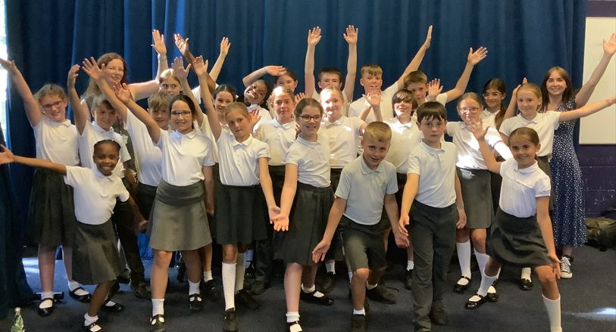
Wow,

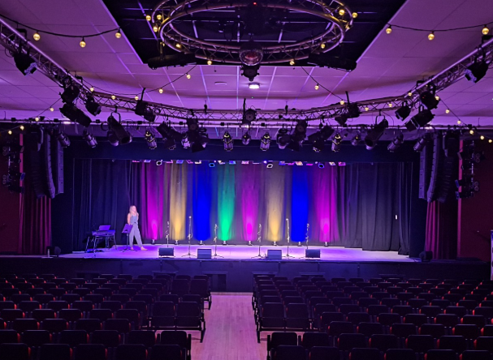

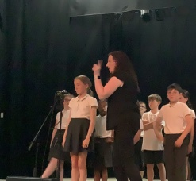


Gainsborough: Jessica & Archer
Medlycott: Mason, Theo, Sam & Lucy
Venn: Eva, Jayden, Isabella & Frida

Beeches

Pre-school have been busy exploring their enquiry about 'How do we travel?' We have been learning all about the different ways of travel by using our bodies and how we move in a range of different ways to how we might travel to get to other countries. We have talked about how we all get to pre-school each day- some of us walk, some of us ride bikes, and some of us come by car. We have had a visit from the fire engine and fire fighters where we asked lots of questions and were all very excited to see the working parts of the fire engine.

Pre-school have also taken part in sports day where we were all amazing at listening and following instructions. We balanced the quoits and completed some obstacle courses in the morning and then completed their running races in the afternoon. We have been practising our ready steady go and we are all very proud of them all for taking part.

Pre-school new email address is beeches.milborneport@acexcellence.co.uk

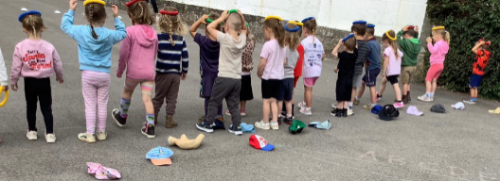

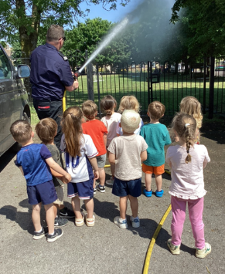

Getting involved with the PTFA—even in small ways—can make a huge difference. By stepping forward to take on a role or lend a helping hand, you will make a meaningful difference to our children’s school experience.
We are encouraged to share that from next year, there will be an active link from the school joining the PTFA, helping to improve communication and coordination. However, we still need parent and carer volunteers to take up the key positions to keep the PTFA alive.
We hope to see you at the AGM , on Thursday 17th July at 3.30pm, and look forward to working together!





