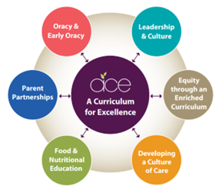


Milborne Port Primary School
Pupil premium strategy statement
2025–2026

This statement details our school’s use of pupil premium funding to help improve the attainment of our disadvantaged pupils.

It outlines our pupil premium strategy, how we intend to spend the funding in this academic year and the effect that last year’s spending of pupil premium had within our school.

School overview

Detail | Data
Number of pupils in school | 139
Proportion (%) of pupil premium eligible pupils | 23% (based on 32 children)
Academic year/years that our current pupil premium strategy plan covers (3-year plans are recommended – you must still publish an updated statement each academic year) | 2025-2028
Date this statement was published | September 2025
Date on which it will be reviewed | September 2026
Statement authorised by | Carmen Danyali
Pupil premium lead | Carmen Danyali
Governor / Trustee lead | Phil Emonson

Funding overview
Detail | Amount
Pupil premium funding allocation this academic year | £59,369
Pupil premium funding carried forward from previous years (enter £0 if not applicable) | £0
Total budget for this academic year  If your school is an academy in a trust that pools this funding, state the amount available to your school this academic year | £59,369

Part A: Pupil premium strategy plan

Statement of intent
At the heart of our curriculum lie three core values: pursuit of academic excellence; the explicit teaching of learning to learn, which includes the development of metacognition; and crucially, character education. We believe that through our curriculum and core principles we can ensure that our very high expectations result in improved outcomes for disadvantaged pupils. This ensures all children will achieve and flourish whilst acquiring life longs skills that enable learners to overcome any barriers to learning and future successes.

Objectives for our disadvantaged Pupils

- We will ensure that the progress of our disadvantaged children will equal or exceed those who are not disadvantaged by implementing our strategy plan. The ACE curriculum plays a central and critical role in accumulating advantage for all pupils, including those that are presently or previously experiencing disadvantage.

- All disadvantaged pupils will be equipped, academically, socially, culturally and emotionally to continue to make progress at their Secondary schools and beyond. Our aim is to ensure that all children leaving our schools are successful learners, curious explorers and healthy thinkers.

Our current pupil premium plan focuses on the following goals (see ‘Accumulating advantage for all’ booklet for more detail)

Strong Leadership that drives:
- Equity through an enriched curriculum (including high quality, well researched and impactful interventions)
- A culture of high quality care
- Food and Nutritional Education
- Effective parent/carer partnerships
- Development of Early Oracy and ongoing oracy skills

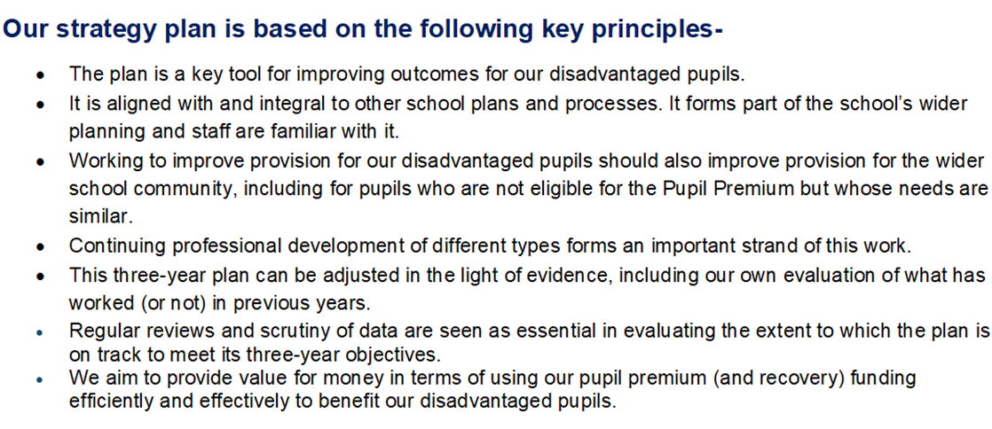

Challenges
This details the key challenges to achievement that we have identified among our disadvantaged pupils.
Challenge number | Detail of challenge
1 | Pupils’ oracy skills: Assessments, observations, and discussions with pupils indicate underdeveloped oral language skills and vocabulary gaps among many disadvantaged pupils. These are evident from Reception through to KS2 and in general, are more prevalent among our disadvantaged pupils than their peers.
2 | Pupils’ phonics and reading ability and lack of parental engagement/ support: Assessments, observations, and discussions with pupils suggest disadvantaged pupils generally have greater difficulties with phonics and reading attainment than their peers. This negatively impacts their development in the overall English attainment.
3 | Pupil’s writing: Assessments show that disadvantaged pupils have greater difficulty in meeting the expected standard in writing.  Across all year groups the disadvantaged gap is the largest in writing. Some of our pupils struggle with written tasks and have negative attitudes towards sustained pieces of writing. Our ACE curriculum is allowing us to challenge these mindsets, although writing outcomes are lower across the school than other subjects
4 | Pupil’s mathematics: Assessments show that disadvantaged pupils have greater difficulty in meeting the expected standard in maths. The gap between the two groups is narrowing but there continues to be a difference between them.
5 | Attendance and persistent absenteeism: Absence and persistent absence is a significant contributing factor to our pupil premium children not achieving as well as non-pupil premium children.

Intended outcomes
This explains the outcomes we are aiming for by the end of our current strategy plan, and how we will measure whether they have been achieved.
Intended outcome | Success criteria
1.To diminish the vocabulary and language gaps (use and understanding of) between disadvantaged and non-disadvantaged pupils.  For richer language and vocabulary choices to be used in a higher percentage of disadvantaged pupils writing, resulting in narrowing the gap in writing attainment between disadvantaged and non-disadvantaged pupils. | All pupils oral acquisition continues to develop rapidly thorough explicit teaching across the curriculum. Teachers to target disadvantaged pupils through the use of adaptive teaching scaffolds and pre and post teaching, in all areas of the curriculum.  WellComm (pre-school) and Language Link (primary school) to support the progress of spoken language for lowest attaining pupils. 90% of disadvantaged pupils to make accelerated progress to close the gap in listening, attention and understanding and speaking Early Learning Goals by the end of EYFS.  These interventions analyse and form the next steps for pupils. These can additionally support with referrals, if needed, to target specific needs.  90% of pupils in EYFS to reach the expected standard in listening, attention and understanding and speaking Early Learning Goals by the end of EYFS.  SLCN intervention programmes are run as an additional resource to high quality teaching  Oracy approach (across the curriculum) is evident in terms of key outcomes for pupils  Our reading strategy is ensuring that by the time children reach Y6 all children are at least at the expected standard, including those on our SEND register  PP children are read with daily, prioritised by class teachers and TA’s. Pre-teach of vocabulary is introduced to children and explained prior to provide more opportunities for children to be successful.  Vocabulary is explicitly taught through quality first teaching and is planned for by class teachers in all subjects.
2. To ensure that progress and attainment in reading and phonics in EYFS and KS1 is broadly in line for disadvantaged and non-disadvantaged pupils. | Attainment in reading at the end of each year group between disadvantaged and non-disadvantaged pupils will narrow annually and be in line by the end of KS2. This includes; Early Learning Goals in EYFS, phonics screening data in Year 1, statutory assessment at KS2 and end of year data for years 1 through to year 5.  Progress in reading and phonics across the school will be broadly in line for disadvantaged and non-disadvantaged pupils. Teachers will closely track attainment and progress of pupils reading through high quality texts, reading lessons, individual reading sessions, guided reading sessions within the taught experiences, and will plan and deliver targeted interventions and pre and post teach sessions to ensure good progress and attainment for all pupils with a focus on disadvantaged pupils.
3 & 4. To raise standards in writing and maths to ensure that attainment and progress for disadvantaged pupils are in line with non-disadvantaged pupils. | Attainment for all pupils will be raised in writing and maths with data for disadvantaged and non-disadvantaged pupils being broadly in line for the static group.  Progress for all pupils will be raised in writing and maths with data for disadvantaged and non-disadvantaged pupils being broadly in line. All children will make expected progress with disadvantaged pupils making accelerated progress where necessary to diminish the gaps.  Data will demonstrate that in reading, writing and maths (combined) the percentage of children achieving ‘on track or higher’ is above the national average by the end of KS2.
5. To continue to provide pastoral support for disadvantaged families and those that are in need of additional support. | SEND assistant continue to work alongside external agencies and teams to work with families needing support and pastoral care. Alongside SLT, we will also make referrals for support in or outside of school. This can also include signposting for financial support and ensuring that all disadvantaged pupils have access to all opportunities in school including clubs and school trips.  SENCo and the SEND team work closely with families to support them with the impact of SEND across the school and at home. This includes, supporting families with referrals to other agencies, needs assessments, programmes of support etc. Pupils that have SEND needs and are disadvantaged are also tracked closely to ensure appropriate progress is made for each child.  The school prioritises well-being and good mental health across the school community through our taught experiences and use of our character gateways. All children are able to access the provision that supports wellbeing and good mental health and data from perception surveys evidences the impact.
5.To continue to ensure that attendance data and persistent absentee data is in line with national data.  To ensure that attendance and persistent absence is in line for disadvantaged and non-disadvantaged pupils. | Continue to contract outside LA (Somerset) and the trust to support the attendance officer and the HT with attendance and ‘lates’.  The HT, SLT and SEND assistant conduct home visits and school based meetings where a family is known to need support and we work to build relationships with them; to identify the root cause; to offer support and ensure that the children are in school including Level 2 intervention (TAF meetings).  Data for disadvantaged and non-disadvantaged pupils is tracked throughout the year to ensure that pupils are making the expected progress identified.  Use of Power BI to support analysis of attendance data.  Prioritise parent meetings and workshops for children with insufficient resources  Continue to ensure all parents take part in learning experience outcomes where parents have the opportunity to share learning, journals and other engaging outcomes.  Meetings with the SENDCO, class teacher and EP will be well attended by PP families.  Parent/carer forums will be well attended by our PP families and individual communication and invites will support this.

Activity in this academic year
This details how we intend to spend our pupil premium funding this academic year to address the challenges listed above.

Teaching (for example, CPD, recruitment and retention)
Budgeted cost: £ 29,474.67 (staffing of SLT & SEND assistant)
Activity | Evidence that supports this approach | Challenge number(s) addressed
1) Use of language link and other oracy strategies to develop communication skills in the Early Years and KS1 | Early Reading framework – Section 2: developing Talk and Appendix 2  EEF – Oral Language Interventions | 1,4
2.)Deliver impactful and bespoke nurture sessions that allow pupils to develop strategies around social skills, self regulation and self expression | EEF social and emotional learning  https://educationendowmentfoundation.org.uk/education-evidence/evidence-reviews/social-and-emotional-learning | 3
3.) Continue to maintain standards in reading though our whole school reading approach  Smaller phonics groups for targeted RWI support. | EEF- Targeted Academic Support  EEF - Early Reading framework – Section 2: developing Talk and Appendix 2  https://educationendowmentfoundation.org. uk/education-evidence/evidence-reviews/ reading-programmes  Implementing a systematic programme (ERF) Early Reading Framework – Section 5: Building a team of experts | 1, 5
4.)Deliver pre teaching sessions and targeted interventions to close gaps for lower attaining children |  | all
5.)Continue to embed the ACE Curriculum and work with all schools across the Trust to embed the curriculum and approaches including attendance at Executive Leadership Team Meetings ((ELTMs) and Trust Improvement Groups (TIGs).  Engage with peer reviews across the Trust. | Leaders working alongside can have an impact on improving quality first teaching:  https://research.acer.edu.au/cgi/viewcontent.cgi?article=1012&context=professional_dev | All
6.)Ensure Quality First Teaching by curriculum leaders having curriculum time to work alongside and coach teachers. This should lead to the gap closing and improved academic attainment of the disadvantaged. | Leaders working alongside can have an impact on improving quality first teaching:  https://research.acer.edu.au/cgi/viewcontent.cgi?article=1012&context=professional_dev | All
7.)Focus on metacognition in all lessons (as part of the ACE Curriculum) to support all learners. Focus on metacognition in staff professional development and in all monitoring activities. This should lead to the gap closing and improved academic attainment of the disadvantaged.  Work with the MAT to develop pedagogy. | Evidence shows that children knowing themselves, how they learn, how they tackle tasks and then what strategies they have available to them which are best for the job impacts greatly on their ability to learn:  https://educationendowmentfoundation.org.uk/education-evidence/evidence-reviews/metacognition-and-self-regulation
8.)Weekly phonics CPD training led by our reading leader for all TAs and teachers delivering phonics. 20 mins/weekly | Leaders working alongside can have an impact on improving quality first teaching:  https://research.acer.edu.au/cgi/viewcontent.cgi?article=1012&context=professional_dev | 1,4
9.) Attendance strategy to be embedded in order to raise attendance and reduce persistent absenteeism for all pupils with a focus on disadvantaged pupils. | -A joined up approach of HT, SLT, and the SEND assistant working with Attendance Officer, Somerset and the trust and to support parents (disadvantaged and non-disadvantaged) in over-coming barriers towards attendance has resulted in a significant improvement in attendance for some individual cases last academic year. | 4, 5

Targeted academic support (for example, tutoring, one-to-one support, structured interventions)
Budgeted cost:
SENDCo x1 afternoon per week: £7340.33
SEND assistant £6, 500
5 teachers providing 40 minutes of mentoring for pupils 1:1 each week: £6,054 (average)

Activity | Evidence that supports this approach | Challenge number(s) addressed
1:1 phonics tutoring – Read, Write Inc | EEF – one to one tutoring | 1,4
1:1 targeted tuition for all PP Year 6 pupils with a teacher. 40 minutes a week for a year | EEF – one to one tutoring | 1,4
1:1 and group fluency intervention -Language link | EEF – improving literacy at KS2 | 1,4
Teachers prioritise pre-teaching in writing for most disadvantaged pupils (vocabulary checks, gathering ideas, plans for writing) | EEF – one to one tutoring | 4

Wider strategies (for example, related to attendance, behaviour, wellbeing)
Budgeted cost:
Breakfast club, afterschool club, food items provided at times of need, swimming, clubs and trips: £10,000

Activity | Evidence that supports this approach | Challenge number(s) addressed
SENDco/Nurture support to support disadvantaged families with  Parenting advice, individual pupil support and referrals for escalated support . | EEF – parental engagement | 3
Breakfast club when required to ensure a soft start regulation time. | EEF – Magic Breakfast Club | 3
Subsidised residentials and trips | EEF – wider opportunities | 2
Additional, healthy food supplied for pupils who are unable to concentrate due to hunger. | European Commission: “Consumption of fresh fruit, vegetables and milk in the European Union does not meet international or national nutritional recommendations. On the other hand, consumption of processed food, which is often high in added sugar, salt, fat or additives, is on the rise.  Unhealthy diets, together with low physical activity, result in obesity. This is why the EU takes action to encourage children to follow a healthy diet and lifestyle.”  Providing free milk and fruit supports disadvantaged children to have a healthy and balanced diet improving focus in lessons. | All
Breakfast programme in place providing free breakfast for every child on arrival to school. | https://www.family-action.org.uk/what-we-do/children-families/breakfast/ | All
PP children are well fed in school, they have good access to food and being hungry is never an issue – nurture group leads to monitor and check in  The trust supports curriculum learning experiences by engaging in cooking with the children and encouraging them to try different foods. | European Commission: “Consumption of fresh fruit, vegetables and milk in the European Union does not meet international or national nutritional recommendations. On the other hand, consumption of processed food, which is often high in added sugar, salt, fat or additives, is on the rise.  Unhealthy diets, together with low physical activity, result in obesity. This is why the EU takes action to encourage children to follow a healthy diet and lifestyle.” | All

Total budgeted cost: £ 59,369

Part B: Review of the previous academic year

Findings relating to our disadvantaged pupils were as follows:

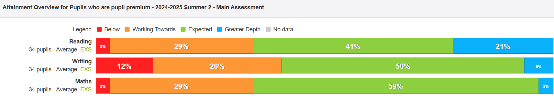
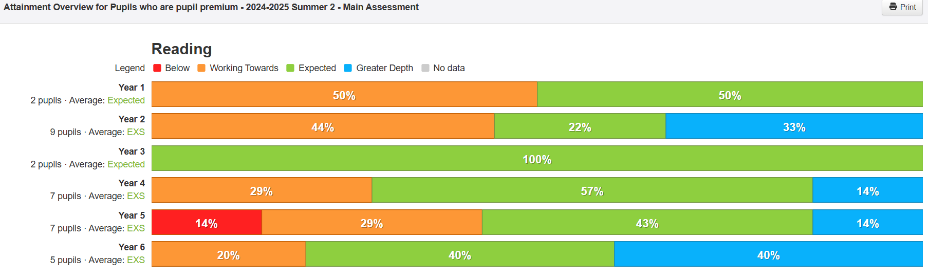
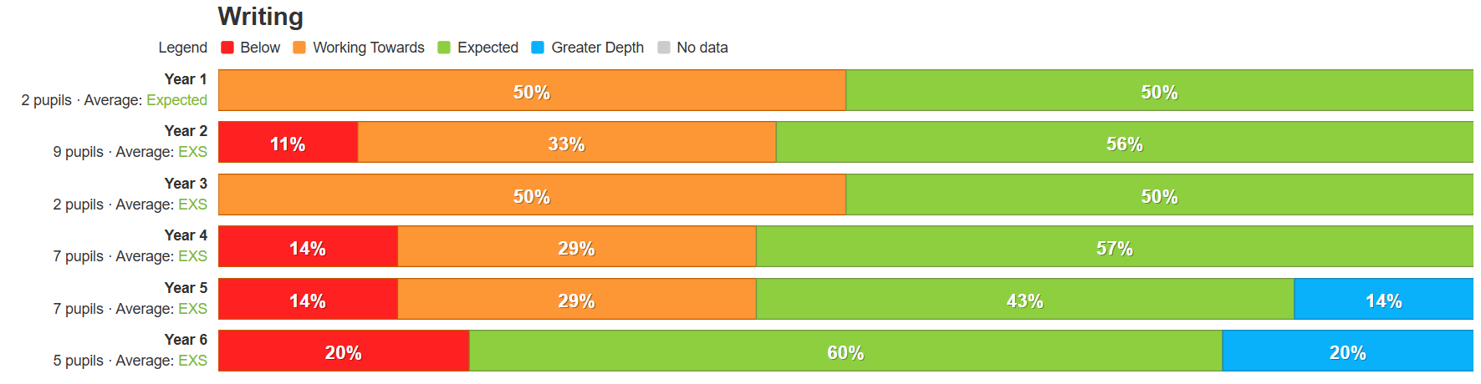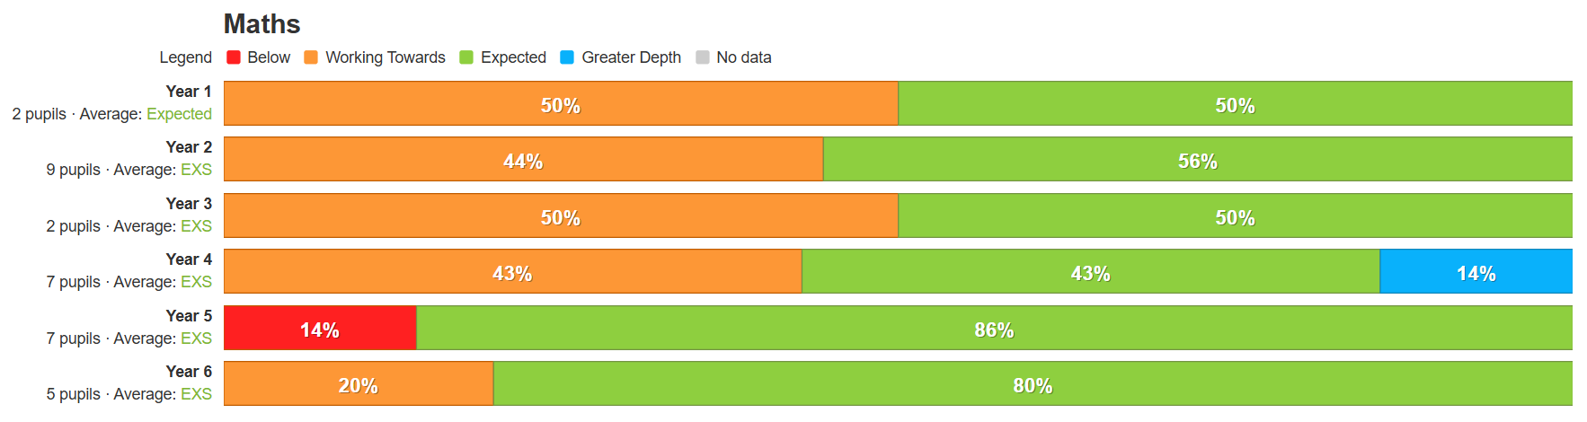

Main Findings

Intended outcome | Success criteria | 24/2025
The ACE curriculum is ensuring QFT is making a difference for our disadvantaged pupils and progress measures show the gap between disadvantaged and others is closing | As a result of careful and focused monitoring our pupils are becoming successful learners (see ACE SL outcomes)
 | Journals reflect progress made in all three areas- metacognition, character education and academic excellence (see individual PP tracker)
 | The progress of disadvantaged pupils is at least the same as the progress of non-disadvantaged pupils and no greater than a 10% difference by the end of KS2 for reading
 | As a result of strong phonics teaching, disadvantaged pupils make accelerated and sustained progress in their writing.
Oracy  All disadvantaged pupils have improved oracy skills and are increasingly able to communicate effectively | Language link programme demonstrates improved language skills for all.
 | Our reading strategy is ensuring that by the time children reach Y6 all children are at least at the expected standard
 | Vocabulary is explicitly taught through quality first teaching and is planned for by class teachers in all subjects. All classes regularly using the ‘remote control’ cards’ to ensure retrieval of learnt vocabulary
 | Our oracy approach (across the curriculum) is evident in terms of key outcomes for pupils.
 | Language link programme demonstrates improved language skills for all pupils taking part in interventions
Enrichment opportunities are providing pupils with the skills and knowledge to become more successful learners | The school seeks meaningful opportunities to broaden pupils horizons eg visiting authors, musical workshops and innovative subject days at our local Secondary schools. This is raising aspirations for children and providing enriching experiences
 | All disadvantaged pupils attend residentials, which are partly funded by the school. Pupils participate in a wider range of sports, team games and develop ACE character traits.
High quality care through SEMH support is ensuring excellent wellbeing and readiness for learning | Pupil outcomes have improved in all areas (academically, socially, emotionally, culturally) as a result of our nurture support and bespoke interventions
 | Pastoral support is well matched to individual need. The school has achieved Trauma informed accreditation ensuring all staff understand the importance of highly effective relational awareness and good mental health for all
 | Soft data identifies that pupils are developing their ability to understand and regulate their emotions
Parent/carer partnerships are strong and parents are increasingly able to support their children’s well being and learning | Improve attendance of disadvantaged pupils to 95%.
 | Prioritise parent meetings and workshops for children with insufficient resources. E.g phonics workshops to ensure improved engagement with home learning
 | Continue to ensure all parents take part in learning enquiry outcomes where parents have the opportunity to share learning, journals and other engaging outcomes

