Wednesday 4th June 2025
Dear Parents and Carers,
I hope this letter finds you well. I am writing to share some extra information regarding our trust and the amazing work that they are doing with our school.

The Academies for Character and Excellence (ACE) is a charitable trust with a mission of Achieving Excellence through Cultivating Character, Sharing Talents and Pursuing Innovation. Our Trust is an exciting and diverse mix of Church of England and Community Schools within Torbay, Devon and Somerset. We are growing a family of schools that prioritises working together in collaborative partnerships which are mutually supportive and share great practice. We truly value the distinctive character of each of our schools and believe that we should be rooted in the communities which we all serve. Our commitment to Character Education is at the heart of our work across the Trust These gateways include, citizenship, leadership, expression, explorers and flourishing. We are uncompromising in our belief that every child fulfils their academic potential whilst also flourishing in and at life.
Over the next 5 years, myself, the school, and the trust team are working together to make some exciting and dynamic changes to the school whist keeping the essence of our village alive. This may include building works, regenerative work, and developing new collaborative working areas for the children.
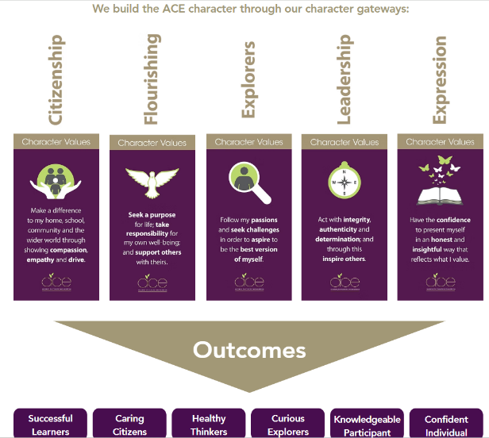
Curriculum:
At the heart of every school lies the curriculum. A successful curriculum is not just a curriculum for the here and now but one that prepares young people for the future. Character Education is fundamental to the pursuit of academic excellence, where knowledge and academic progress work in tandem with the development of character traits as well as the ability to become an ‘expert’ learner.
​
At the heart of our Character Education curriculum lie three core values: pursuit of academic excellence; the explicit teaching of learning to learn which includes the development of metacognition; and crucially, character development.
​
Our vision for success is measured against six key outcomes, each one reflecting our core values. Our outcomes are not designed to be hierarchical but instead underpin our view that the purpose of the curriculum is to educate for the future.

As a school, we have been working alongside our trust since September to develop these practises within Milborne Port Primary School and I myself have led this alongside other members of the school since January.
New staff from September:

Unfortunately, as the end of the academic year approaches, we will also be saying goodbye to a number of staff who are moving on to new roles and opportunities. While we are sad to see them go, we are grateful for their hard work, dedication, and the positive impact they have had on our pupils and the wider school community. We will be taking the time to celebrate their contributions before the end of term, and we wish them every success in the future.

We have actively recruited new members of staff which include Mrs Churchward, who will be staying with us permanently now, and Mrs Ross joining us from September. Additionally, we will welcome back Mrs Carr from maternity leave. These members of staff share our school, trust and community vision and enthusiasm, and we confident that our team will continue to go from strength to strength.

Class structure for next year:

Due to changes in pupil numbers and funding in education in general, we made the decision 18 months/ 2 years ago to reduce from six to five classes. We were extremely lucky to stay at 6 classes in the academic year of 2025-2026 however it has always been the plan financially to reduce the school to 5 classes. As a result, Milborne Port Primary School will be returning to mixed-aged year groups as you are aware. This is a common and effective approach used by many schools in the surrounding area, and we are confident that, with thoughtful planning and high-quality teaching, all children will continue to thrive. We are currently finalising the new class structure, lists and placement of teachers and will share full details with you shortly, including information about your child’s class and teacher.

We understand that change can bring questions, and we are committed to supporting you and your child/ren every step of the way.

In September I will be launching the new vision for our school and the new signage and logo is due to be placed on the school building over the next couple of weeks.

Thank you, as always, for your continued support.
Warm regards,
Miss C. Danyali
Headteacher
Milborne Port Primary School

